|  |
| --- |
| **KIET Group of Institutions, Ghaziabad**  ***CS Department***      **Internship Report**  **On**  **Student Record Management System**  **Using C.**      **Summer Internship at KIET Group of Institution**  **Mini Project**    **(Duration)**  **(2022)**    **Submitted By :**  **Abhishek Rajput**  **B.TECH/CS**  **(Sem.3-Sec.A)**  2100290120007 |

**INDEX**

1. **Acknowledgement**
2. **Certificate**
3. **Abstract**
4. **Introduction**
5. **Details of Task**
6. **Conclusion**
7. **Future Scope**
8. **Research paper**
9. **MOOC certificate**

**ACKNOWLEDGEMENT**

I’ve got this golden opportunity to express my kind gratitude and sincere thanks to my Head of Institution, KIET Group of Institutions of Engineering and Technology, and Head of Department of **CS** for their kind support and necessary counselling in the preparation of this project report. I’m also indebted to each and every person responsible for the making up of this project directly or indirectly.

I must also acknowledge or deep debt of gratitude each one of my colleague who led this project come out in the way it is. It’s my hard work and untiring sincere efforts and mutual cooperation to bring out the project work. Last but not the least, I would like to thank my parents for their sound counselling and cheerful support. They have always inspired us and kept our spirit up.

**ABHISHEK RAJPUT**

**B.TECH-CS**

**SEMESTER-3**

**2100290120007**

**CERTIFICATE**

This is to certify that the internship project report entitled **Student Record Management System** submitted by ABHISHEK RAJPUTin the Department of **CS** of KIET Group of Institutions, Ghaziabad, affiliated to Dr. A. P. J. Abdul Kalam Technical University, Lucknow, Uttar Pradesh, India, is a record of candidate summer internship. He has successfully completeted his internship under my supervision and guidance and is worthy of consideration for the same.

**Signature of Supervisor:**

**Supervisor’s Name: Date:**

**Student record management system :**

**Abstract**: Student Database Management System provides a simple interface for

maintenance of student information. It can be used by educational institutes or colleges to maintain the records of students easily. The creation and management of accurate, up-to-date information regarding a students’ academic career is critically important in the university as well as colleges. Student information system deals with all kind of student details, academic related reports, college details, course details, curriculum, batch details, placement details and other resource related details too. It tracks all the details of a student from the day one to the end of the course which can be used for all reporting purpose, tracking of attendance, progress in the course, completed semesters, years, coming semester year curriculum details, exam details, project or any other assignment details, final exam result and all these will be available through a secure, online interface embedded in the college’s website. It will also have faculty details, batch execution details, students’ details in all aspects, the various academic notifications to the staff and students updated by the college administration. It also facilitate us explore all the activities happening in the college, Different reports and Queries can be generated based on vast options related to students, batch, course, faculty, exams, semesters, certification and even for the entire college.

**Introduction**: This system provides a simple interface for the maintenance of student

information. It can be used by educational institutes or colleges to maintain the records of students easily. Achieving this objective is difficult using a manual system as the information is scattered, can be redundant and collecting relevant information may be very time consuming. All these problems are solved using online student information management system. The paper focuses on presenting information in an easy and intelligible manner which provides facilities like online registration and profile creation of student’s thus reducing paper work and automating the record generation process in an educational institution.

**Details of task :**

**#include<stdio.h> void addstudent(); void studentrecord(); void searchstudent(); void delete(); struct student { char first_name[20]; char last_name[20]; int roll_no;**

**char Class[10]; char vill[20]; float per;**

**}**

**void main()**

**{ int choice; while(choice!=5){**

**printf("\t\t\t=====STUDENT DATABASE MANAGEMENT SYSTEM=====");**

**printf("\n\n\n\t\t\t\t 1. Add Student\n"); printf("\t\t\t\t 2. Students Records\n"); printf("\t\t\t\t 3. Search Student\n"); printf("\t\t\t\t 4. Delete Student\n"); printf("\t\t\t\t 5. Exit\n"); printf("\t\t\t\t ___\n"); printf("\t\t\t\t "); scanf("%d",&choice);**

**switch(choice){**

**case 1:**

**addstudent();**

**break; case 2:**

**studentrecord();**

**printf("\t\t\t\t press any key to exit..... \n"); return 0;**

**break;**

**case 3:**

**searchstudent(); printf("\n\t\t\t\t Press any key to exit.......\n");**

**return 0;**

**break;**

**case 4:**

**delete(); printf("\n\t\t\t\tPress any key to exit.......\n"); return 0; break; case 5:**

**printf("\n\t\t\t\tThank you, for used this software.\n\n");**

**exit(0); break; default : return 0; printf("\n\t\t\t\t\tEnter a valid number\n\n"); printf("\t\t\t\tPress any key to continue......."); return 0; break;**

**}**

**}**

**return 0;**

**}**

**void addstudent(){**

**char another; FILE *fp; int n,i; struct student info; do{ printf("\t\t\t\t=======Add Students Info=======\n\n\n");**

**fp=fopen("information.txt","a"); //use can give any file name. Give the name with extention or without extention.**

**printf("\n\t\t\tEnter First Name : "); scanf("%s",&info.first_name); printf("\n\t\t\tEnter Last Name : "); scanf("%s",&info.last_name); printf("\n\t\t\tEnter Roll-No : "); scanf("%d",&info.roll_no); printf("\n\t\t\tEnter Class(course) : "); scanf("%s",&info.Class); printf("\n\t\t\tEnter Address : "); scanf("%s",&info.vill); printf("\n\t\t\tEnter Percentage : "); scanf("%f",&info.per); printf("\n\t\t\t______\n");**

**if(fp==NULL){ fprintf(stderr,"can't open file");**

**}else{ printf("\t\t\tRecord stored successfuly\n");**

**}**

**fwrite(&info, sizeof(struct student), 1, fp); fclose(fp);**

**printf("\t\t\tYou want to add another record?(y/n) : ");**

**scanf("%s",&another);**

**}while(another=='y'||another=='Y');**

**}**

**void studentrecord(){**

**FILE *fp;**

**struct student info; fp=fopen("information.txt","r");**

**printf("\t\t\t\t=======STUDENTS RECORD=======\n\n\n");**

**if(fp==NULL){**

**fprintf(stderr,"can't open file\n");**

**exit(0); }else{ printf("\t\t\t\tRECORDS :\n"); printf("\t\t\t\t___\n\n");**

**}**

**while(fread(&info,sizeof(struct student),1,fp)){ printf("\n\t\t\t\t Student Name : %s %s",info.first_name,info.last_name); printf("\n\t\t\t\t Roll NO : %d",info.roll_no); printf("\n\t\t\t\t Class : %s",info.Class); printf("\n\t\t\t\t Village/City : %s",info.vill); printf("\n\t\t\t\t Percentage : %f%",info.per); printf("\n\t\t\t\t ____\n");**

**}**

**fclose(fp); return 0;**

**}**

**void searchstudent(){ struct student info; FILE *fp; int roll_no,found=0;**

**fp=fopen("information.txt","r"); printf("\t\t\t\t=======SEARCH STUDENTS RECORD=======\n\n\n");**

**printf("\t\t\tEnter the roll no : ");**

**scanf("%d",&roll_no);**

**while(fread(&info,sizeof(struct student),1,fp)>0){**

**if(info.roll_no==roll_no){**

**found=1; printf("\n\n\t\t\tStudent Name : %s %s",info.first_name,info.last_name); printf("\n\t\t\tRoll NO : %d",info.roll_no); printf("\n\t\t\tClass : %s",info.Class); printf("\n\t\t\tAddress : %s",info.vill); printf("\n\t\t\tPercentage : %f%",info.per);**

**printf("\n\t\t\t______\n");**

**}**

**}**

**if(!found){ printf("\n\t\t\tRecord not found\n");**

**}**

**fclose(fp); return 0;**

**}**

**void delete(){ struct student info;**

**FILE *fp, *fp1;**

**int roll_no,found=0;**

**printf("\t\t\t\t=======DELETE STUDENTS RECORD=======\n\n\n"); fp=fopen("information.txt","r"); fp1=fopen("temp.txt","w"); printf("\t\t\t\tEnter the roll no : ");**

**scanf("%d",&roll_no); if(fp==NULL){ fprintf(stderr,"can't open file\n");**

**exit(0);**

**}**

**while(fread(&info,sizeof(struct student),1,fp)){ if(info.roll_no == roll_no){**

**found=1;**

**}else{ fwrite(&info,sizeof(struct student),1,fp1);**

**}**

**}**

**fclose(fp); fclose(fp1);**

**if(!found){ printf("\n\t\t\t\tRecord not found\n");**

**}**

**if(found){ remove("information.txt"); rename("temp.txt","information.txt");**

**printf("\n\t\t\t\tRecord deleted succesfully\n"); }**

**return 0;**

**}**

**Output:**

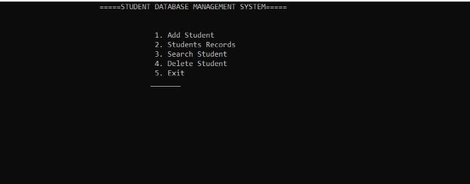

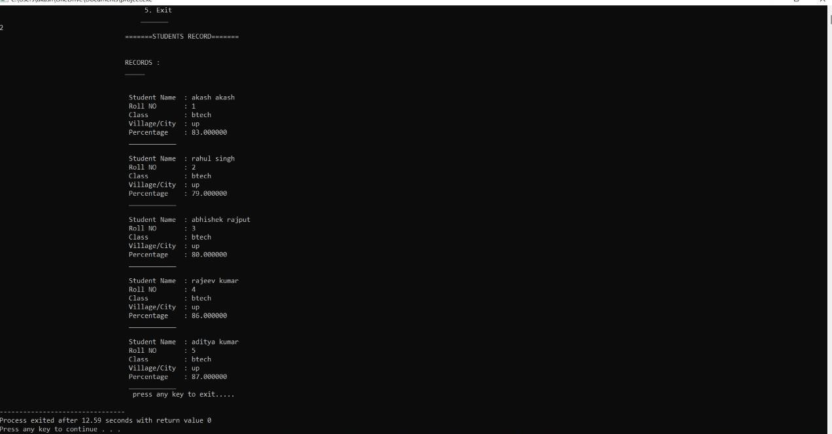

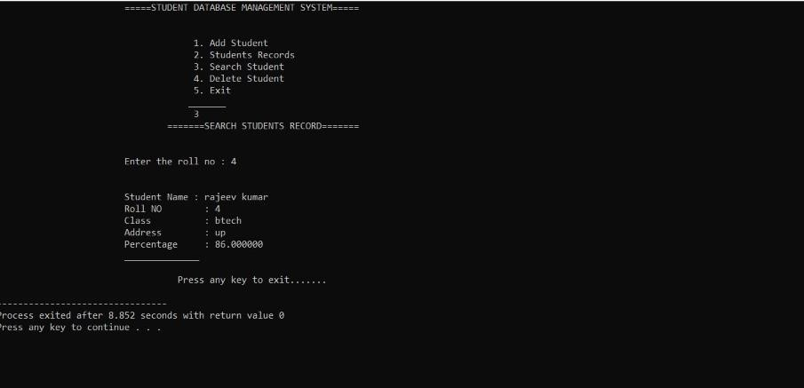

**Conclusion of Internship :**

**Although the student database management module is not fully integrated to the system and used on real time, the system prototype demonstrates easy navigation and data are stored in a systematic way. Overall, efficiency has improved and work processes simplified. Although all the objectives have been met, the system still has room for improvement. The system is robust and flexible enough for future upgrade using advanced technology and devices.**

**Future scope of work :**

The following is just a sample of future opportunities that would help sustain the portal for undergraduates:-

1. One can upgrade this web portal to store subject video lectures under different professor names and also maintain the previous year’s question papers in it.
2. The portal can be used to take day to day attendance and automatically send an SMS to the students and their parent.
3. One can deploy this web application into mobile android application and be used in smaller devices like mobile phones, tablets and notepads.
4. In future web portal can be combined with the university internal and external web sites. So that all courses in the university will have single web app.
5. Students can directly fill a resume forum system will use artificial intelligence and sent the resume to companies as per student requirement and eligibility criteria.